42.3: Let 1 refer to C and 2 to O.
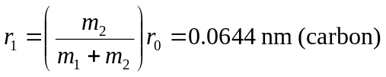
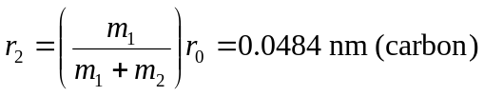
b) yes, this agrees with Example 42.2.

